SPECIFICATION:

Screw: M4 x 10 Csk Torx (T20) M/S St Zi.

Applicable standards:
DIN 965 or ISO 7046-1 (DIN EN ISO 7046-1)

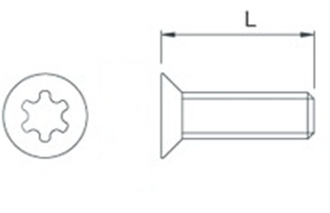
Screw size: | M4
Length, L: | 10mm
T-Drive | T20
Material: | Zinc-plated steel (Must be RoHS Compliant)

Note 1: Part /Component to be RoHS Compliant

